### **Summary of Findings and Implications**

* **Correlation Between Rising Temperatures and Wine Production:**
  + **Findings**: The analysis shows a correlation between rising median temperatures and wine production. Correlation does not imply causation, but there’s a lot of data to make use of here.
  + **Implications**: Wine producers in areas where climate change will have an impact will need to adapt to changing climatic conditions to resume production.
* **Emergence of New Wine Industries in Warmer Regions:**
  + **Findings**: The data does not directly address this question. However, trends imply potential shifts in wine production geographically.
  + **Implications**: As temperatures rise, regions previously unsuitable for wine production will turn into new wine-producing areas.

### **Precise Descriptions and Findings for Each Project Question**

* **Correlation between Rising Temperatures and Wine Production:**
  + The data presents a correlation, supported by linear regression analysis. More varied data would enhance the precision of this response.

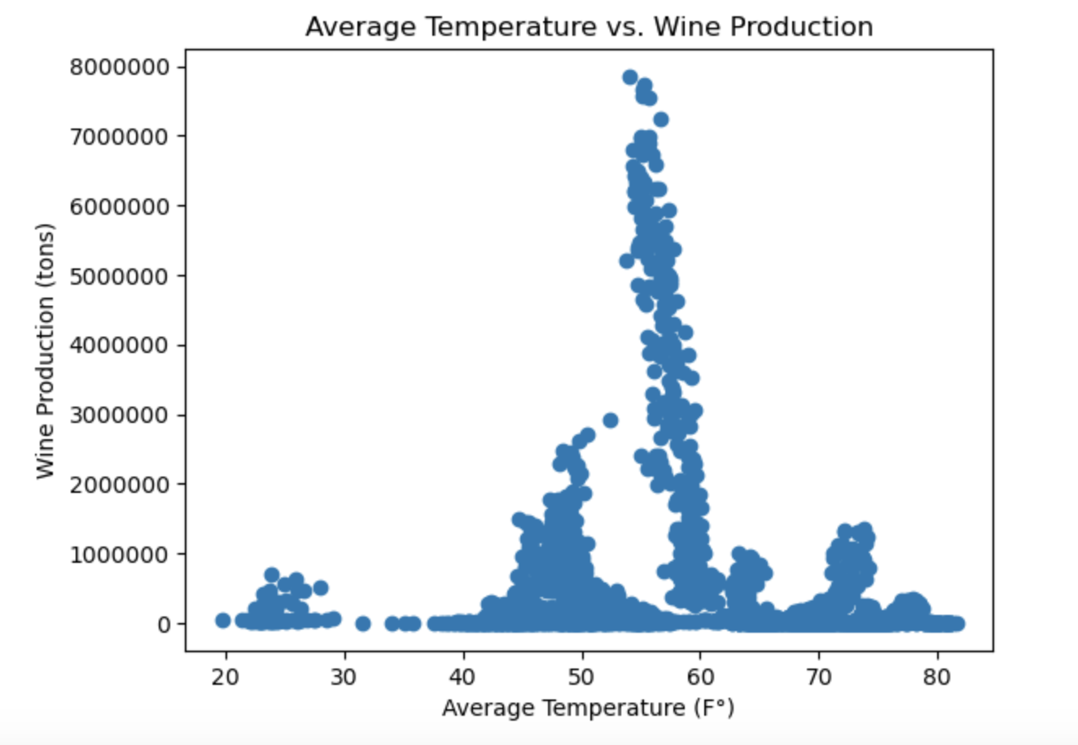

* **Correlation between Rising Temperatures and New Wine Industries:**
  + There isn't a strong correlation between rising temperatures and new wine industries, however there is a trend that can be analyzed further with more varied data.

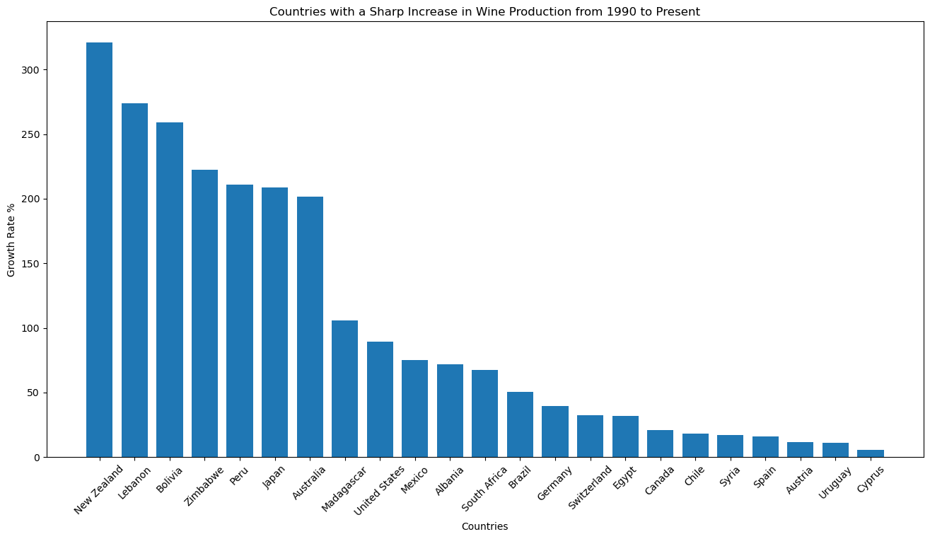

* **Geographical Changes in Wine Production Due to Temperature Rise:**
  + The analysis of different time periods shows changing trends in wine production, but lacks specific geographic pinpointing. Further analysis is needed to precisely map these changes to geographical regions.

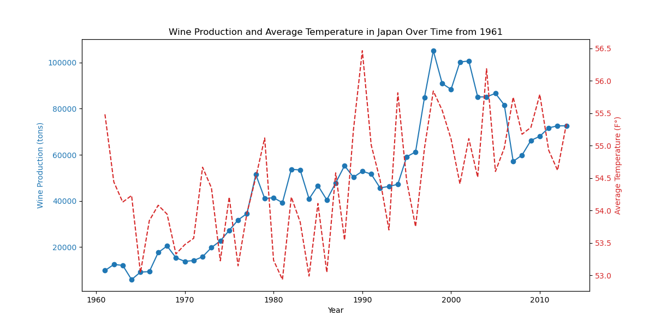

### 

### **Findings Supported with Numbers and Visualizations**

* **Scatter Plot and Regression Analysis:**
  + A scatter plot with a regression line illustrating the relationship between median temperature and wine production.
  + Statistical figures (r-value, p-value) from the regression analysis.

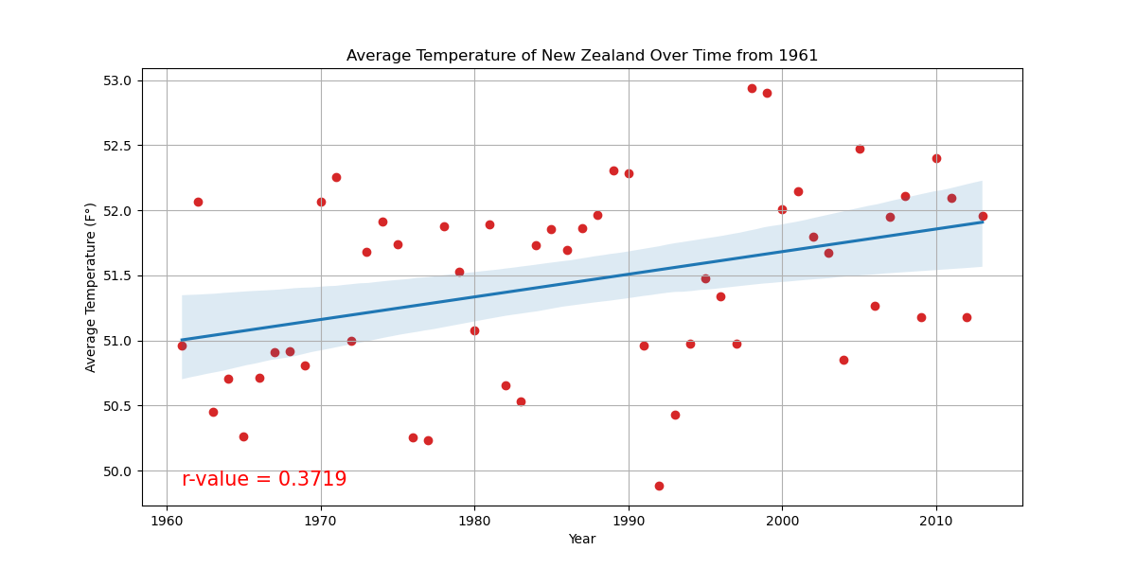

* **Bar Chart of Wine Production Growth:**
  + A bar chart depicting growth rates in wine production in various countries, indicating possible geographical shifts.

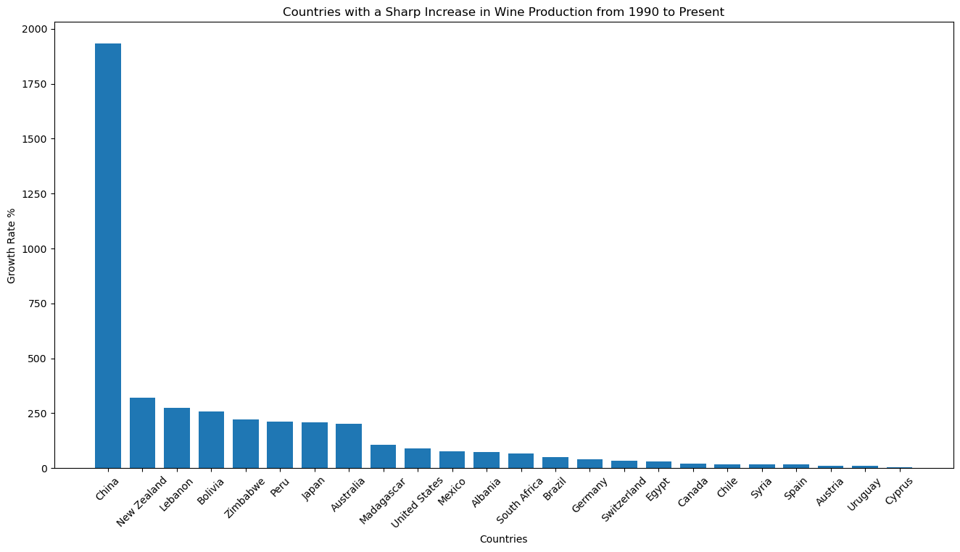

### **Statistical Analysis Supporting Each Response**

* **Correlation Analysis:**
  + Linear regression to determine the relationship between temperature and wine production.
  + Reporting of correlation coefficients and p-values to assess statistical significance.

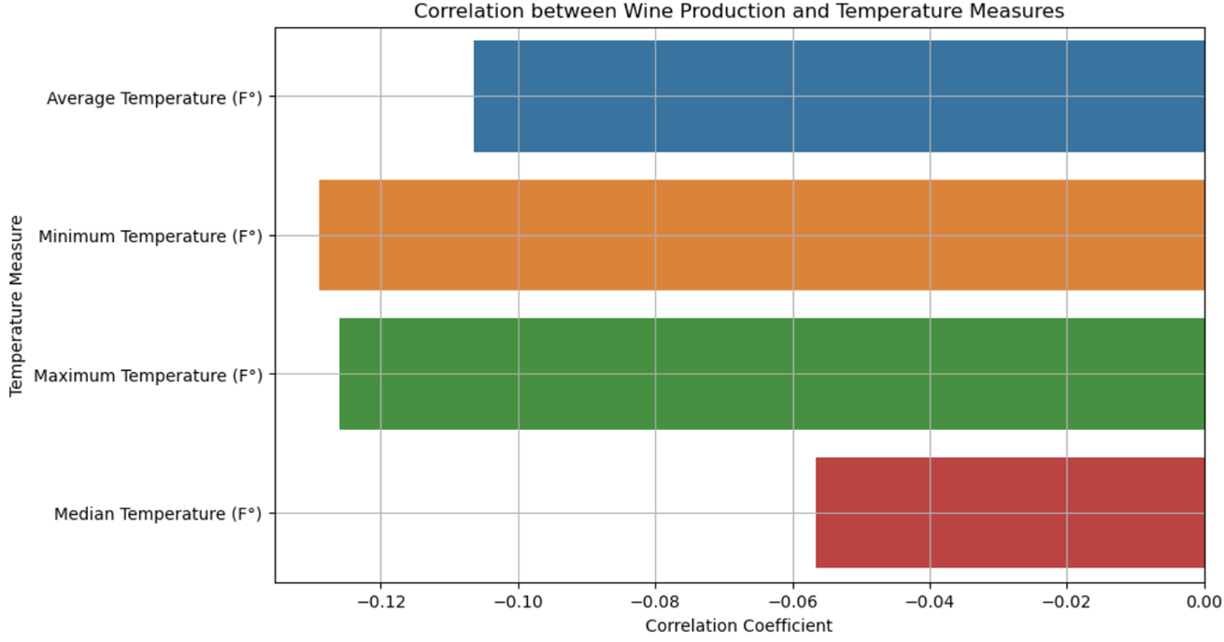

* **Comparative and Geographical Analysis:**
  + Comparative analysis over time to identify trends in wine production.
  + Geographical analysis (suggested for future research) to map the impact of rising temperatures on global wine production.

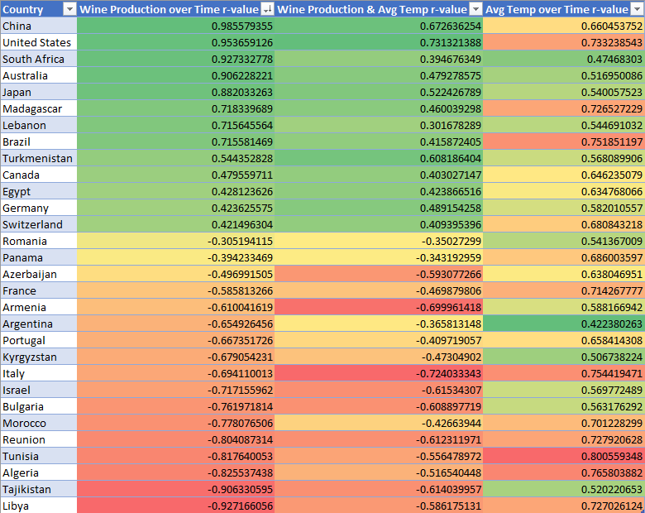

### **Conclusion**

This project underscores the potential impact of climate change on the wine industry, suggesting a shift in wine production patterns globally. The findings call for adaptive strategies in viticulture and highlight the importance of continued research in this area. We find correlation between rising temperatures and wine production volume, however we can’t claim this correlation implies causation. Detailed numerical data and targeted geographical analysis are needed for more definitive conclusions.